E-commerce Project Documentation

1.INTRODUCTION

# Overview

The primary goal of an e-commerce site is to sell goods online. This project deals with developing an e-commerce website for Online Product Sale. It provides the user with a catalogue of different product available for purchase in the store. In order to facilitate online purchase a shopping cart is provided to the user.

E-commerce is an advanced way of conducting businesses online and across the borders and because of that it has various advantages to it: Its reach is across the global market and with minimum investments. It enables sellers to sell their products on a global level and allows customers to make a broader choice.



# Purpose



An e-commerce website is one that allows people to buy and sell physical goods, services, and digital products over the internet rather than at a brick-and-mortar location. Through an e-commerce website, a business can process orders, accept payments, manage shipping and logistics, and provide customer service.



* Reduced overhead costs
* No need for a physical storefront
* Ability to reach a broader audience
* Scalability
* Shop from anywhere
* Browse a wide range of product

2.LITERATURE SURVEY

# 2.1 Existing Problem

* Potential security threats



* When you’re doing business online, there’s always the potential for security threats. Poor website security can allow unauthorized users to gain access to your website and look at sensitive data.
* Competition
* This is one of the biggest e-commerce disadvantages because it means you have to work extra hard to make sure you’re promoting your store and driving traffic to your website.
* Limited connection with customers
* You don’t get a chance to connect with customers on a personal level when you’re running an e-commerce store.
* IT issues
* There are no tech issues that can keep you from accepting cash at a physical store, but IT issues can be a big problem for e-commerce websites
* Methods to solve these problems



* E-commerce solutions refer to a set of software and technology tools that help businesses sell products and services online. These solutions typically include a website or online storefront, a shopping cart, payment processing systems, and inventory management tools.
* Empathize: Show that you understand their frustrations and dissatisfaction. Apologize: Even if the issue isn't your fault, provide a sincere apology for what happened (or didn't happen). Resolve: If possible, resolve the issue quickly and provide follow-ups as necessary

# 2.2 Proposed Solution

* + - Select your perfect ecommerce
    - Purchase a domain name.
    - Find a developer.
    - Pick your ecommerce theme.
    - Customize your ecommerce template.
    - Add your products.
    - Set up payment options.
    - Sort out your shipping settings.

3.THEORITICAL ANALYSIS

# 3.1 Block Diagram

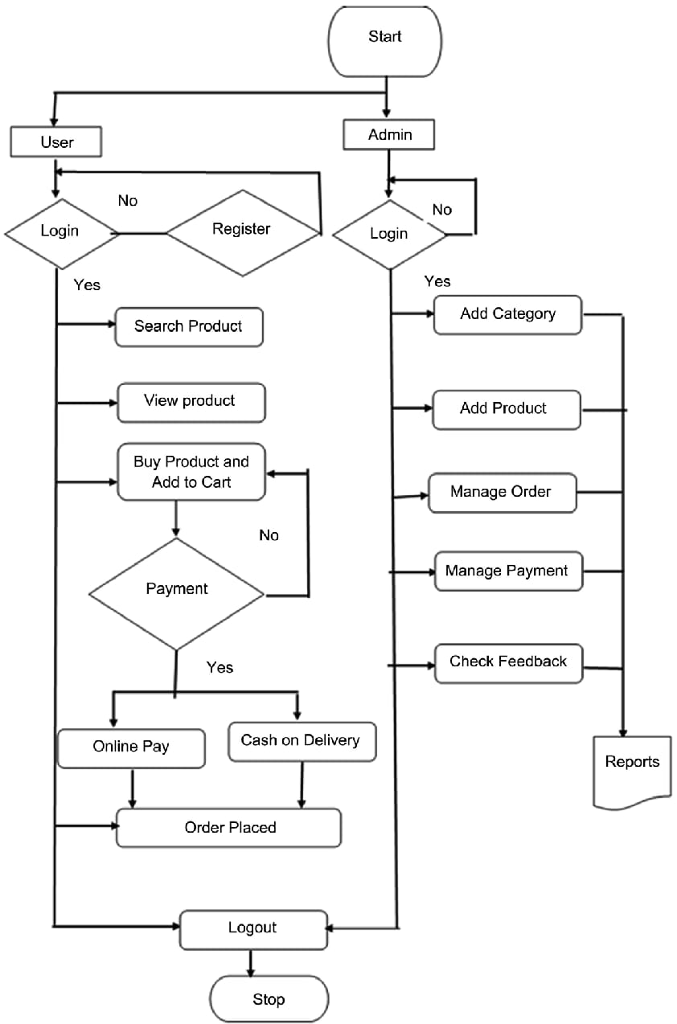

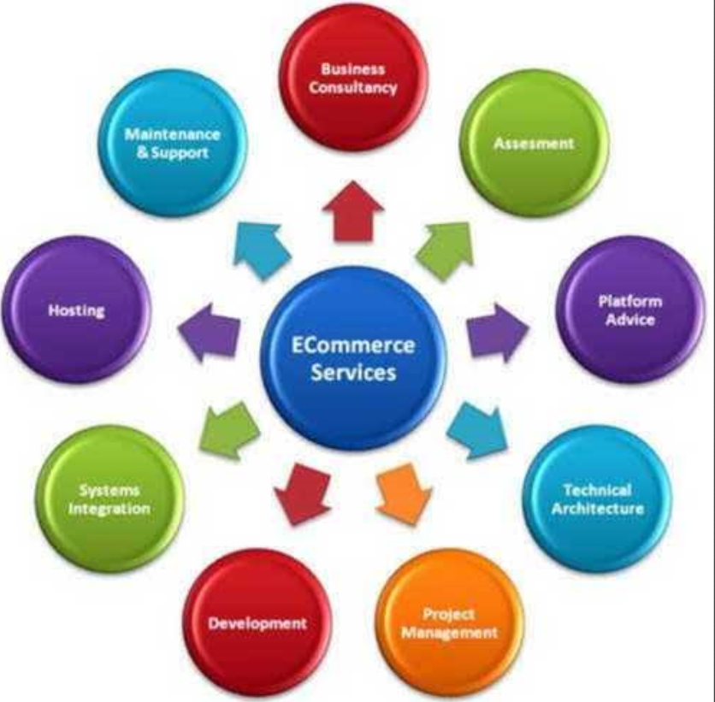



# 3.2 Hardware/Software Designing

Storage Devices, Input Devices, Output Devices, and Internal components are the primary categories of hardware.

External Hard Drive. Given that most things are done online these days it's important to have some kind of hard drive to store information in. ...

Desktop/Laptop Computer.

Network Server.

Mobile device.

VS Code.

Operating Systems, Application Software, and Programming Software are the main categories of software.

Windows11.

Google Chrome.

MS Word.

4.RESULT

This project is about Ecommerce Appliances Mart. This project includes Homepage, Products page, Categories page, new arrivals page and Contact details. When we click on “Home” image carousel will be appeared. When we click on products it displays the featured products. In similar way when we click on categories, new arrivals, contact us it displays top categories page, new arrivals page and contact us details.

In top categories we have home appliances, kitchen appliances, cleaning appliances, bathing appliances. By clicking on shop now button it will go through corresponding appliances pages.

In the recommended products we have add to cart buttons, by clicking on the button the products will be added to the cart. We can also remove the products from the carts.

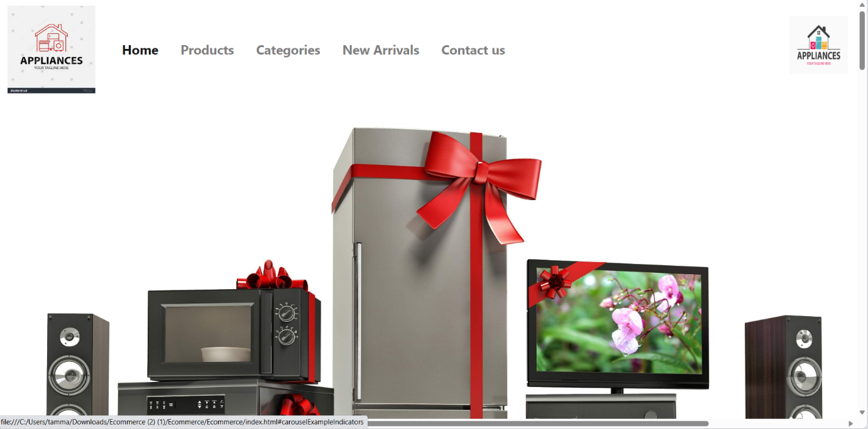

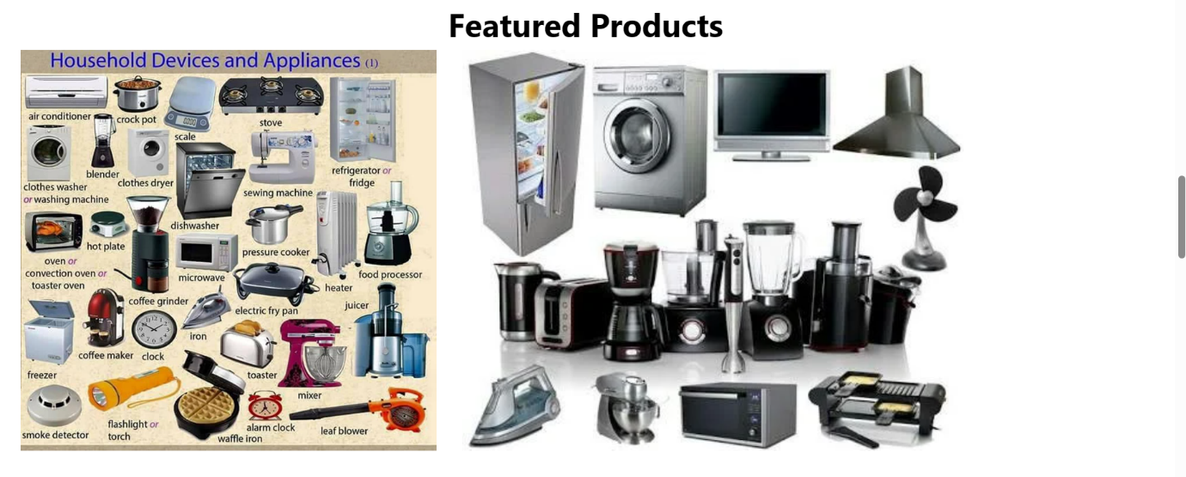

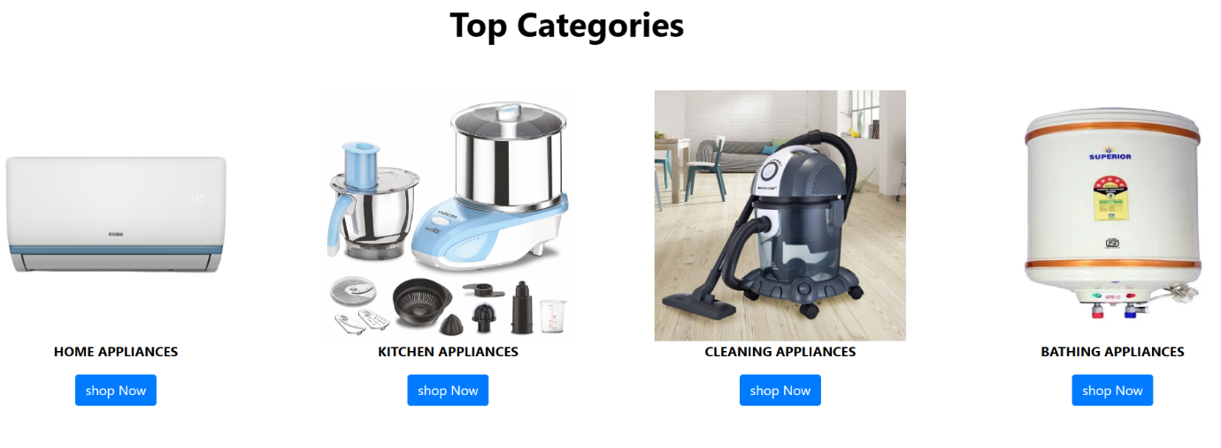



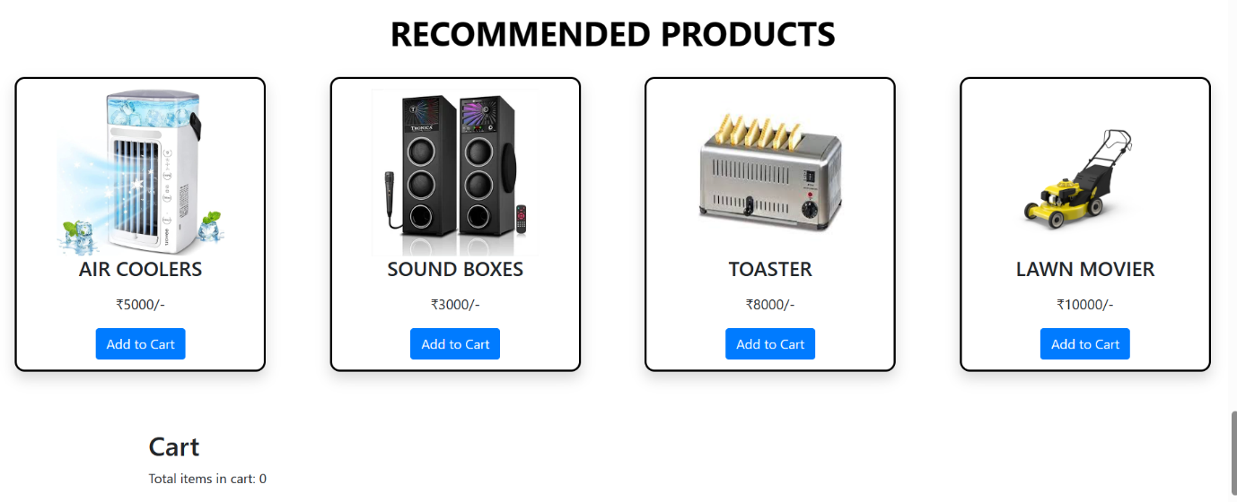



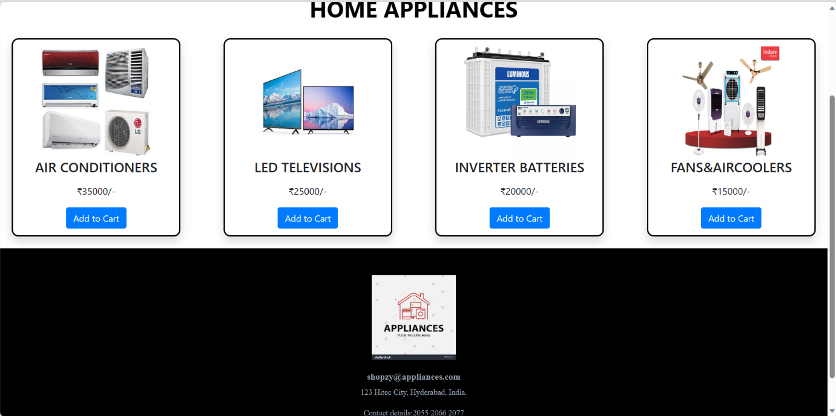

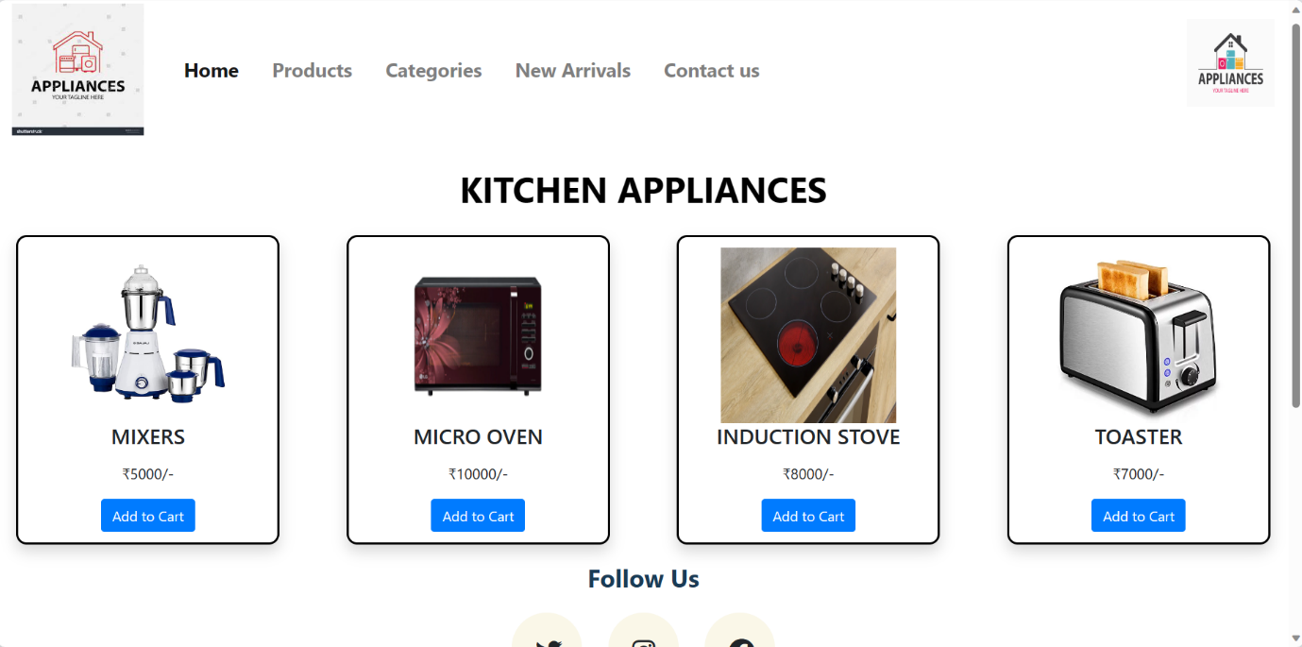

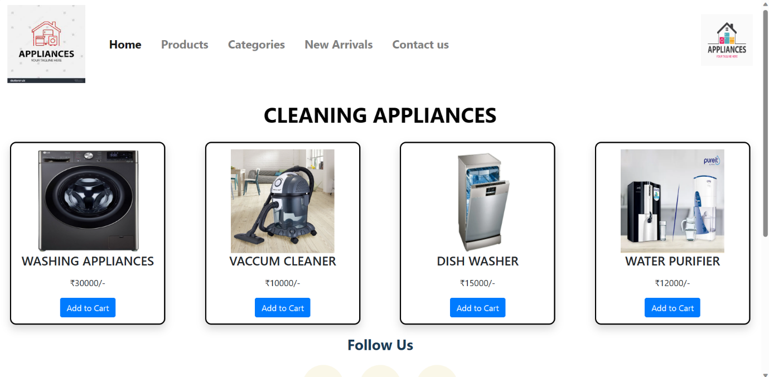

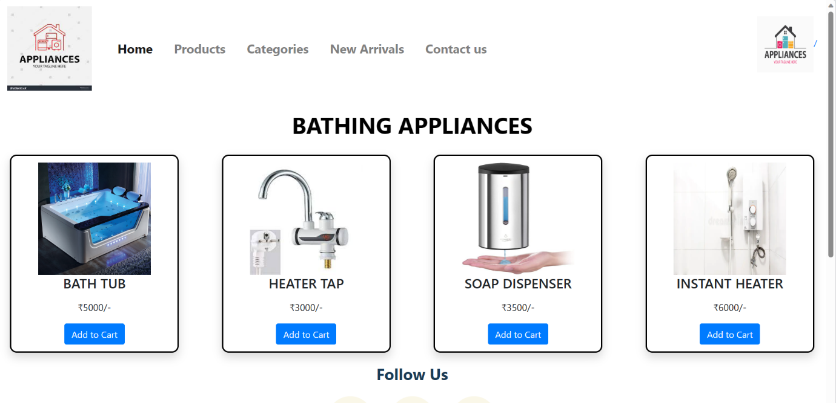

5.ADVANTAGES AND DISADVANTAGES

* Advantages

Essentially, flexibility and time-saving are two of the biggest benefits of online shopping. eCommerce enables shoppers to purchase products and services at their leisure and convenience 24/7. Moreover, shoppers can place their orders or browse other stores from the comfort of their homes.

Advantages of Ecommerce:

There are a number of prominent and not-so-obvious advantages for doing business on an online platform. Understanding exactly how e-Commerce works can help individuals leverage them to their and their businesses advantage:

* A Larger Market: E-Commerce allows individuals to reach customers all across the country and all around the world. E-Commerce gives business owners the platform to reach people from the comfort of their homes. The customers can make any purchase anytime and anywhere, and significantly more individuals are getting used to shopping on their mobile devices.
* Customer Insights Via Tracking And Analytics: Whether the businesses are sending the visitors to their eCommerce website via PPC, SEO, ads, or a good old postcard, there is a way of tracking the traffic and the consumers’ entire user journey for getting insights into the keywords, marketing message, user experience, pricing strategy, and many more.
* Fast Response To The Consumer Trends And The Market Demands: Especially for the business people who do “drop ship,” the logistics, when streamlined, allow these businesses to respond to the market and the trends of eCommerce and demands of the consumers in a lively manner. Business people can also create deals and promotions on the fly for attracting customers and generate more sales.
* Lower Cost: With the advancement of the eCommerce platforms, it has become very affordable and easy to set up and run an eCommerce business with a lower overhead. Business people no longer need to spend a big budget on TV ads or billboards, nor think about personnel and real estate expenses.
* More Opportunities For “Selling.”: Business people can only offer a limited amount of information about a product in a physical store. Besides that, eCommerce websites give them the space to include more information like reviews, demo videos, and customer testimonials for helping increased conversion.

Disadvantages

Disadvantages of e-Commerce

Running a business that is e-commerce is not always rainbows and unicorns. There are unique challenges to this business model — learning about them will help business people navigate the choppy waters and avoid common pitfalls.

* Lack of Personal Touch: Some customers appreciate the personal touch they offer when visiting a physical store by interacting with the sales associates. Such personal touch is especially essential for businesses that sell high-end products as customers will want to buy the products and have an excellent experience during the process.
* Lack of Tactile Experience: No matter how good a video is made, customers still can’t feel and touch a product. Not to mention, it’s never an easy task to deliver a brand experience that could often be including the sense of touch, taste, smell, and sound via the two-dimensionality of any screen.
* Product and Price Comparison: With online shopping, customers can compare several products and find the least price. This forces many businesses to compete on price and reduce their profit margin, reducing the quality of products.
* Need for Access to the Internet: This is obvious, but don’t forget that the customers do need access to the Internet before purchasing from any business! As many eCommerce platforms have the features and functionalities which require a high-speed Internet connection for an optimal consumer experience, there’s a chance that companies are excluding visitors who have slow internet connections.
* Credit Card Fraud: Credit card frauds are a natural and growing problem for online businesses. It can lead to many chargebacks, which result in the loss of penalties, revenue, and a bad reputation.

6.APPLICATIONS

Many retail e-commerce apps use online marketing techniques to get customers to use the platform. These include email, online catalogues and shopping carts, Electronic Data Interchange (EDI), file transfer protocol, web services and mobile applications.

E-commerce solutions refer to a set of software and technology tools that help businesses sell products and services online. These solutions typically include a website or online storefront, a shopping cart, payment processing systems, and inventory management tools.

7.CONCLUSION

E-commerce still represents one of the business methods that take advantage if done the right way, even if the stock market and commodities fell, but E-Commerce still able to survive and receive high transaction.

The study concludes that there would be a prospective growth of e-commerce in India, if the Government provide a legal security and framework for e-commerce and the domestic and international trade are allowed to expand their basic rights such as intellectual property, privacy, prevention of fraud, consumer protection.

An ecommerce business plan is a document that outlines your business purpose and goals, analyses your industry and competitors and identifies the resources needed to execute your plan.

8.FUTURE SCOPE

1. Voice Search.
2. Visual Search.
3. Influencer marketing.
4. Omnichannel connected experience.
5. Video Engagement.
6. Cognitive virtual assistants.
7. Virtual consultation.
8. AI-based hyper personalization.

* E-commerce has a promising future as new technological and commercial breakthroughs open up several growth opportunities. It's an interesting and diversified market to start a business. However, it may also be very competitive, given the growing number of e-commerce websites.

